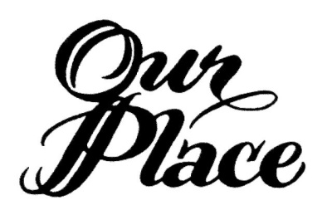

New Beginnings Referral Form
New Beginnings 2019 Ten-Week Class Dates
Mothers: August 28, 2019 from 4:00 p.m. to 6:00 p.m.
Fathers: August 29, 2019 from 4:00 p.m. to 6:00 p.m.
Facilitators: Susan Hudson, M.Ed. and Neta White, M.Ed.
Cost: $65
Classes will be held at Our Place, Inc., 400 East Spring St., New Albany, IN 47150
To register, contact Susan Hudson at 812-945-3400, ext. 110 or susanhudson@ourplaceinc.org
Date of Referral: ________________________________________
Referred By: ________________________________________
Client(s) Name: ________________________________________
Client(s) Contact Information: _____________________________
Case Number: __________________________________________
Client to contact Our Place, Inc. by this date: ___________________________
Please email or fax this Referral Form to: susanhudson@ourplaceinc.org or 812-945-9870
Celebrating Over 35 years of Service Since 1981
Our Place Drug & Alcohol Education Services, Inc.
400 E. Spring Street * New Albany, IN 47150
812-945-3400 * 1-800-276-9773 * 812-945-9870 (fax) * www.ourplaceinc.org

